Document the design of your game, including the data structures and algorithms used, in a brief design document

Space invaders  
**Game Concept Describe the game concept here in 2-3 sentences. Focus on what the player can DO.**

Space invaders is a 2d on rails shooter that sees you defending earth from invading aliens scrolling down from space with a blaster that shoots bullets as you dodge and weave through returning bullets.

Space invaders  
**Technical Goals What are the technical aspects of your game that your team aim to deliver? E.g. Challenging AI, Procedural Generated   
Levels, Interesting Jetpack mechanics.**the goals are to make a functional space invaders clone, that will have random firing from the aliens and point accumulation from the player as they aim to shoot down the aliens

GitHub is the source control being used as I have found it to have the most intuitive user interface, as well as the fact that I have the most experience with it.

<https://github.com/muildy/space-invaders-project>

Game Objects and Scripts Provide necessary technical details for any technical team member to implement at least the skeleton for each system in   
your game, including classes/functions/properties/interfaces/inheritance/relationships. This can be done with:  
• One or more UML Class and/or Collaboration diagrams describing the static architecture and  
• One or more Sequence and/or Activity diagrams describing specific parts of the run-time behaviour. These are   
often in response to a particular use-case  
• Supporting text to help explain the diagrams, when and if necessary  
For example, include class diagrams for each Game object that requires a custom script, and include information about   
what it does, what data types it manages, and other notes a programmer might need to write that code

**Gameplay Systems Describe in more detail your individual gameplay systems, including how they interact with other systems in your game,**Description: Enter description of gameplay system

Movement to the left and right as to dodge randomly fired alien bullets

The ability to fire bullets back

Cover to hide behind

The aliens will scroll from left to right moving down whenever an alien touches the edge of the screen

A mothership will occasionally scroll across the screen, shooting it will give extra points

The less aliens on screen, the faster they move  
Diagrams: Include UML diagrams, if possible  
  
  
User Interface Add user-interface design mock-up. Display any differences between PC and Mobile interfaces.  
Figure 3 Example Mock-up Main Window  
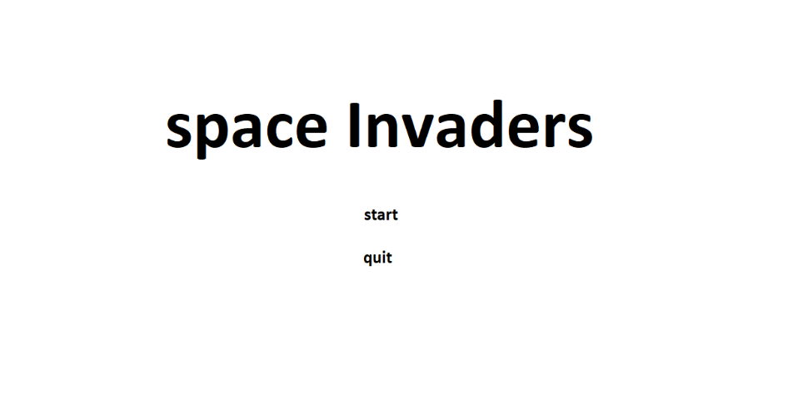

A title of the game and two buttons,

The title states “space invaders” and the buttons say “start” and “quit”

The start button leads directly into the game,

And the quit button terminates the window.